Multi-Agent System Notes
- An Application Science for Multi-Agent Systems, T.A. Wagner
  - “A Complex Systems Perspective on Collaborative Design,” M. Klein, P. Faratin, H. Sayama, Y. Bar-Yam, pp. 77-93
Different aspects of design done so as to locally maximize module while meeting influence constraints to other modules. Iterative system
Find global optima in these design networks of collaborative design
  - “Multi-Agent System Interaction Protocols in a Dynamically Changing Environment,” M. Purvis, S. Cranefield, M. Nowostawski and M. Purvis
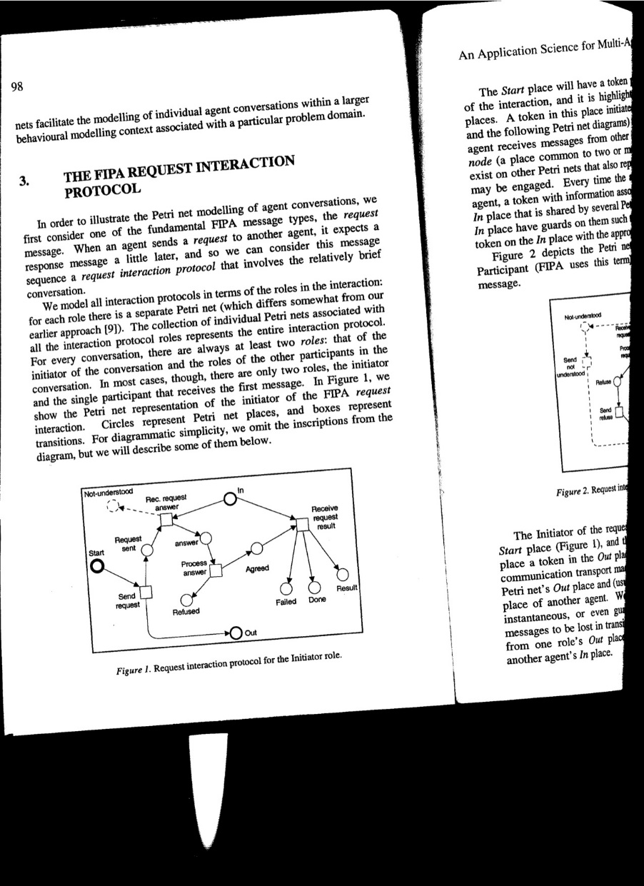

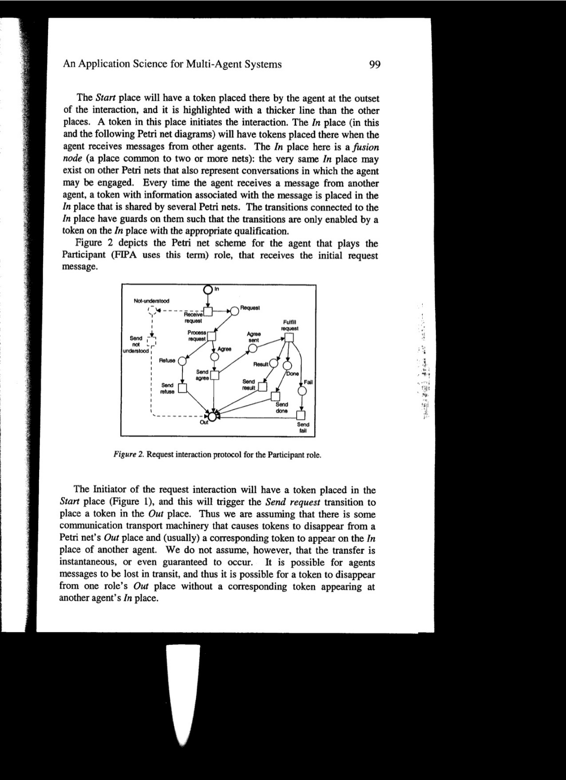

Weiss book: http://www.the-mas-book.info/
Vlassis 2007:
http://www.uma.ac.ir/files/site1/a_akbari_994c8e8/a_concise_introduction_to_multiagent_systems_and_distributed_artificial_intelligence__synthesis_lectures_on_artificial_intelligence_and_machine_learni.pdf

