- Identification
Title of proposal: | A Shape Display – Renewal
Name of principal investigator: | Elaine Cohen
Name of university or institution: | University of Utah
Department: | School of Computing
Date of submission:
Technical committee: | AIM | (AIM or COMM)

- Research Objective
Current computer displays are primarily visual. However, even with high-resolution, stereo, head-tracked displays, understanding complex three-dimensional data is still a frustrating experience. We propose to build a shape display to allow combined visual and haptic exploration and manipulation of computer data. We hypothesize this will dramatically improve one's ability to understand, manipulate, and interact with digital shapes, data, and designs.
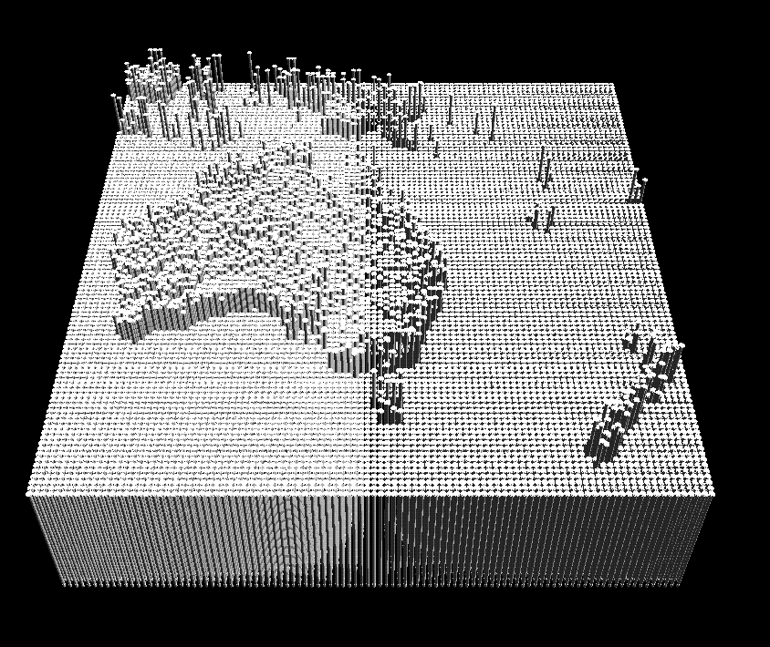
Figure 1: A simulation of a high-resolution shape display showing terrain data.
Previous efforts at shape and tactile displays have consisted of actuated arrays of shape elements, or pins. Actuators small enough to pack densely together are still on the order of ten millimeters in diameter, have limited stroke length of around 10 millimeters, and cost hundreds of dollars. These factors limit the affordability, feasible resolution, and density of a shape display.
The key element of our approach is to separate the shape elements from the actuation. Essentially, the shape display will be made of two distinct elements:
- a high-resolution array of passive shape element pins.
- a shape “print head” of a few high-performance actuators that travels below the high resolution array and moves the passive pins.
Since the shape element pins don’t need to accommodate the width of the actuator, this approach allows a high density packing of shape element pins. Much greater economies of scale are possible as well, since the passive pins needn’t be more complicated that a simple plastic part. Essentially, this approach trades off device bandwidth for higher resolution and lower cost. More importantly, we feel it is the first approach capable of displaying high-resolution shapes.
A shape display has the potential for driving computer applications into areas that have been considered too complex or frustrating for computer assistance. By creating a new mode of interaction with a computer, human talents at interpreting shape are more naturally paired with digital computation. The research task is to develop interface and shape rendering techniques using the shape display and to pair these with these new applications.
- Background
Understanding and manipulating a virtual object is a fundamental interface activity. Traditionally, this manipulation has been for two-dimensional objects such as a cursor, for which standard displays and interfaces are well suited. Three-dimensional interface methods are still considered difficult and cutting-edge. Besides this predominantly visual-oriented research, two communities have led attempts to understand complex computer generated shapes. The robotics community has developed mechanical systems and software to allow local exploration of shape by touch. The tactile community has developed systems for representing small, high-frequency tactile sensations. We discuss some of these approaches below.

Haptics
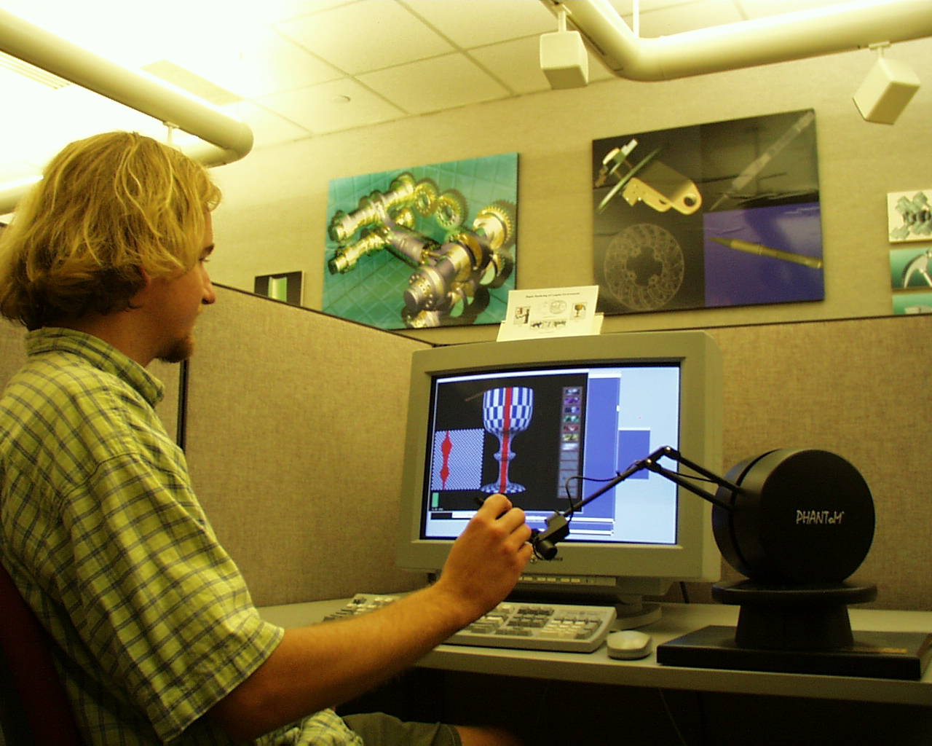
Figure 2: Haptic devices usually only provide local exploration of shape.
Current haptic devices are usually mechanical arms that attach to the user's hand or body. They generate forces either at a single point, as in the three DOF PHANToM, or at a series of powered joints in an antromorphic arm, as with the SARCOS Dextrous arm. Other haptic devices provide special purpose simulation support, such as the Impulse engine for surgical simulation. These devices simulate the contact forces that would be generated from touching an object. The contact forces must be simulated at high rates, around 1000 Hz, to maintain sensations of solid contact. Sophisticated geometric algorithms are needed to compute contact states between virtual objects.

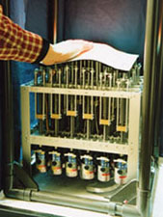

Figure 3: Project FEELEX has 36 actuated pins moving a sheet.
There have been previous experiments in creating deformable surfaces for shape display. However, these experiments have typically attempted to actuate all the pins of the display, limiting the resolution of the devices.
The most recent and impressive device is Hiroo Iwata’s project FEELEX, with a 6x6 actuated array (Figure 3). The limited resolution makes it difficult to distinguish any actual shape in the display. However, this device was impressive enough to be presented at SIGGRAPH 2001, showing that the graphics community is interested in the basic concept of a shape display.
A different approach is the WYSIWYF (What You See Is What You Feel) Display [3] This "encountered-type" display depends on producing physical standins for the virtual objects in the scene. A robotic arm moves the physical objects into the correct place so that the user's hand encounters them and has actual physical contact. This technique requires a large workspace for the moving arm, a collection of predetermined shapes to present to the user, and, for safety, careful body tracking, all of which limit the capabilities of this sort of display.

Tactile
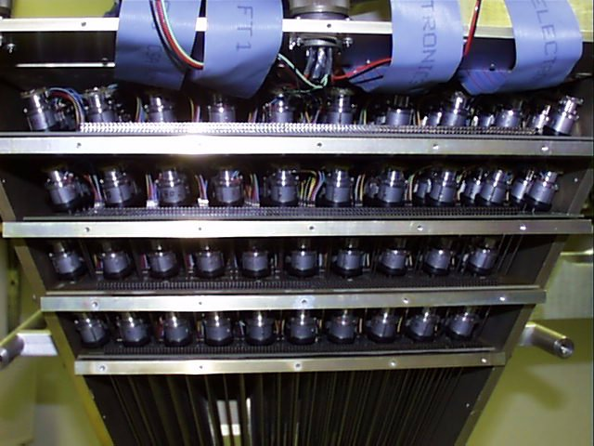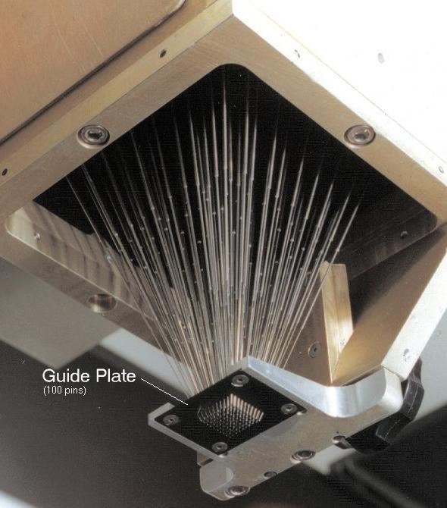
Figure 4: A large tactile array.
The tactile community has built higher resolution devices, but they have limited height displacement. Examples of these are a 20x20 pin tactile array in development at the JHU Somatosensory Labs (Figure 4). The Medical Physics Group at the University of Exeter has also built a 10x10 pin tactile array. Each device is used for stimulating the pad of a finger and has very limited vertical displacement, on the order of a millimeter.
Our research goal differs from the haptic and tactile communities in that we generate an actual shape, rather than forces simulating contact with an object. While there are significant engineering challenges in constructing this device, the research opportunity lies in developing techniques for using such a device as a computer interface.
The research team for this project is uniquely suited to face the development challenges. We have a research CAD system and manufacturing lab that provide the capability of rapidly designing and testing prototypes for the shape display. We have considerable expertise in haptics, having pioneered the use of CAD models in haptic environments. We have designed and built mechanical and robotic devices. Finally, we have long experience in computer graphics and computer interfaces – providing the perspective that at one point, graphics displays were slow and limited, but have developed into a necessity of the computing experience.

The Utah Team
The Utah team is uniquely positioned to make progress on this difficult mechanical and computer algorithms problem. First, the primary research thrust of our lab has been in the development of CAD/CAM software, which, in conjunction with the equipment in our Advanced Manufacturing Lab, gives us the capability of designing and manufacturing the custom pieces needed for the shape display. Secondly, an important area of recent research for us has been the development of many of the fundamental algorithms for haptic interfaces, which provides us with the background and motivation to explore this even more advanced interface device. Finally, the principal members of the team are a mix of computer science and mechanical engineering researchers, which gives us the background to tackle all phases of the shape display development. This team approach has already paid off in the successful development of our prototype device.
- Project Status
The primary goal of our first year effort has been to validate our overall approach of separating the elements of the shape display from the means of positioning them. Towards this end, we have
- designed and built a series of increasingly sophisticated shape display prototypes and prototype components of the final system,
- manufactured an initial injection mold for the plastic pins and done some trial manufacturing,
- developed a set of software tools and graphical simulators to control our prototype shape displays and validate our larger designs.

A Prototype Shape Display
Our main effort has been in developing the proper design and controls for allowing the actuators to move below the shape element pins, attach to a selected pin, move the pin up or down to the desired position, detach from the pin and travel to the next pin. Our initial concept was to have a hook on the actuator that could attach to a notch near the bottom of the pin and thereby move it up or down.
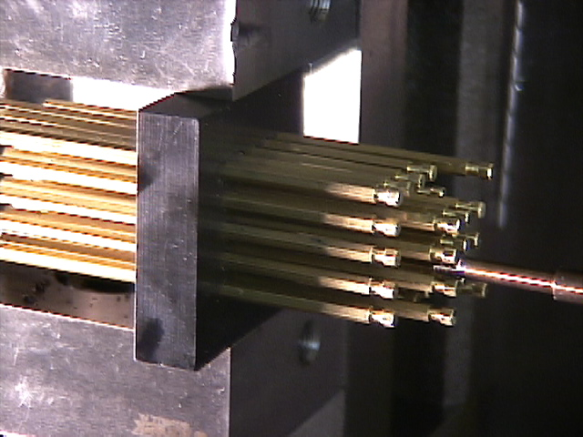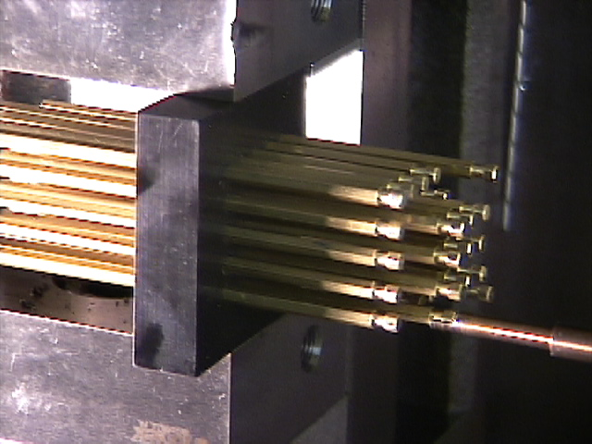
Figure 5: The prototype 5x5 shape display. Here the “hook” has approached a pin and then attached to the “notch” in preparation for movement. This view shows the back side of the display, normally the viewer would be in front, looking at the top of the pins. The hook is controlled by a CNC milling machine robot.
We have been refining this concept using a 5-axis CNC milling machine as the actuation system and a set of metal pins in a plastic plate as the passive elements. There have been three main refinements from our experiments:
- The original design used round pins as the shape elements. Round pins in round holes need to be manufactured to high tolerances else the pins will either not fit or will be too loose to be held in place. The design for the pins has been changed to have a hexagonal shaped body, a round head, and a round notch. The round head and notch are needed or else the pins would have to be held in a consistent orientation for packing and attaching. The hex body provides room for the plastic to deform while being held in its hole and permits finer control of the friction between the pin and hole.
- We have modified the initial hook design so that it requires very little clearance in between rows of pins. This permits the final design to have a higher density of shape elements.
- In our original hook and notch design, the hook and notch were made to have tight tolerances so that the position of the pin would be tightly coupled to the position of the hook when they were attached. This led to some difficulty attaching and detaching the hook and required high precision from the test CNC machine. In our new design, the notch is larger than the hook, which requires slightly different control strategies from the actuator, but still allows precise positioning and alleviates attachment/detachment problems.

Manufacturing Injection Molds for the Shape Elements
This project is somewhat unusual in that in order to build a prototype device with thousands of pins, we need to mass produce the custom shaped pins. Earlier in the year we made an initial injection mold for the plastic pins. The molds had an alignment error, but gave us the confidence that the next attempt, incorporating the design changes from above, will be manufacturable.

Software Controllers and Simulators
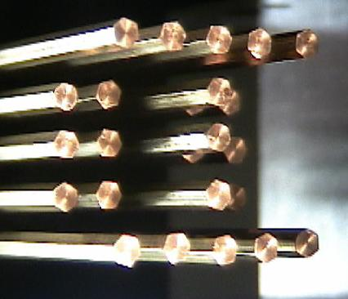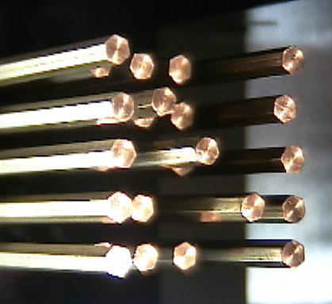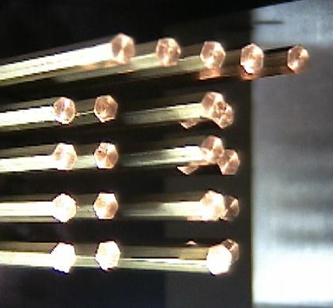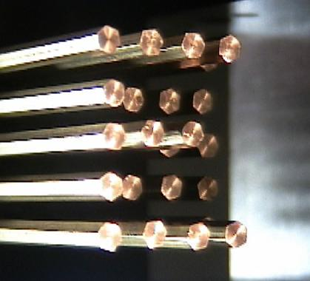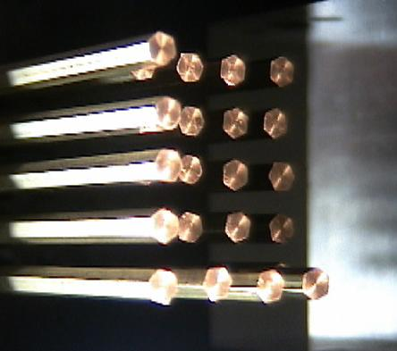
Figure 6: The software controls the prototype to spell out INTEL one letter at a time. The reflective pins and lighting make the pictures more difficult to see than on actual device.
We have developed a graphical simulator and controller to run our prototyping experiments. This software reads a series of grayscale images as height field maps, converts the changes in height to a set of robot actuator commands, and displays the simulated shape display as a graphical three-dimensional model. We have used this code to run our prototype device in its first real test, spelling out the letters, UTAH INTEL one after another on a 5x5 metal pin array.

The Next Generation Device
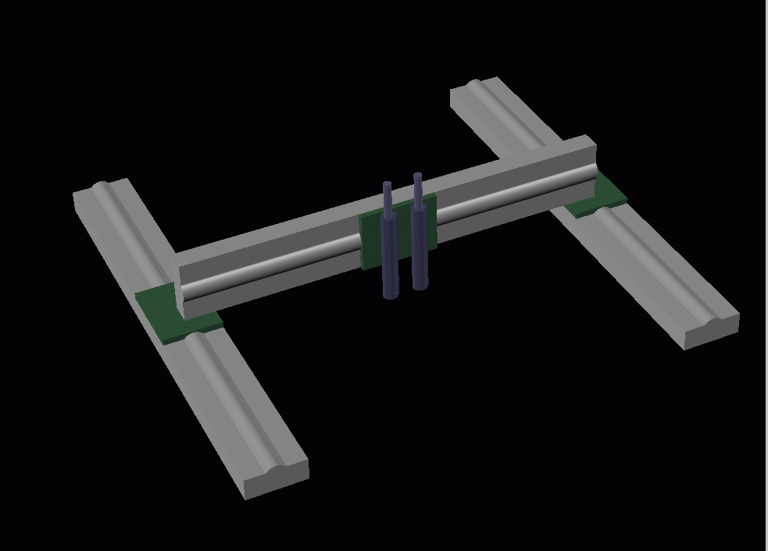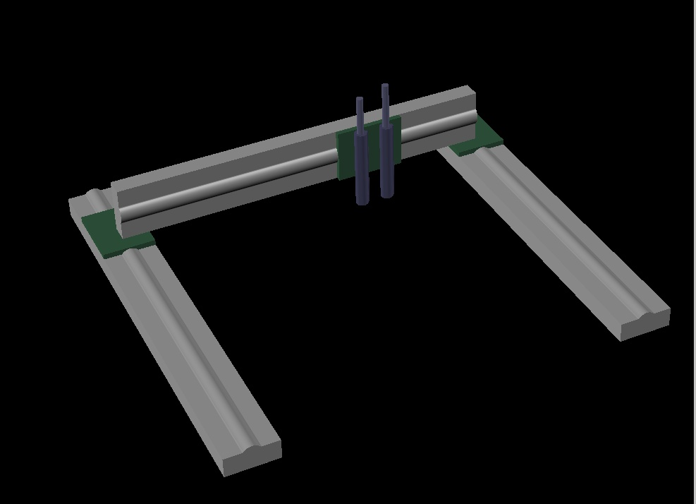
Figure 7: The design of the next-generation device is a gantry style XY positioning system, which provides greater stability and an interference free work volume. The model is shown with two pin actuators, although the final design can include more. The pins would be suspended above the positioning table.
Finally, considerable effort has been devoted to researching and designing the mechanical system for the first large-scale shape display. We have leveraged equipment funds from other grants along with the Intel research money to purchase a very high performance base for the next year effort. We have designed a system with large linear motors for the XY travel and a set of four actuators to move the pins. The actuators can all produce several g’s of acceleration, travel at a high velocity, and move with 10-100 micron precision. We expect that this system will be capable of setting 50-150 pins per second. Delivery of these components is expected at the end of September.
- Knowledge Transfer
The technical lead for this project, David Johnson, traveled to Intel this last spring. He presented a talk to a local audience and over Intel’s teleconferencing system. Even though the talk was fairly preliminary, he had useful talks with researchers at Intel about ways to incorporate a working shape display into human-computer interfaces.

Knowledge Transfer Plans
We have several plans for increased Intel contact and participation in the upcoming year with our Intel Research Council contact.
- We expect to publish papers on the basic concept of the shape display as well as on applications from it. We have discussed with our Intel contact ways for him to participate in this process.
- Another visit to Intel is anticipated when the next-generation display is working.
- This device should be very interesting to watch and experiment with and we hope to display the device in forums such as SIGGRAPH’s emerging technologies exhibit.
- We continue to discuss appropriate ways to protect Utah’s and Intel’s intellectual property rights and potential commercial possibilities.
- Breakthroughs and Problems
The biggest breakthrough was validating our initial concept for a shape display. We have now run enough experiments and tests that we have confidence that the idea of decoupling the actuators from the pins, allowing us to scale up the resolution of the device, works and works well. The small prototype built works well and is already similar in performance to existing devices. The other main breakthrough was the design of the next generation device, which leaps ahead in performance beyond our original goals.
The one main problem we had was in our initial production of plastic pins for the shape elements. The injection mold for the pins is a complex manufacturing problem, using several advanced processes such as electro-discharge machining, and in the end a simple error produced an alignment error in the mold. However, this led us to go back and validate our design more carefully and we have made some changes in the pins, so that we are now ready to proceed once again with a better design.
- Revised Goals and Plans
With the small prototype shape display working and giving us confidence in our approach towards building a high-resolution device, and with the equipment ordered for the next-generation device, our plans for the upcoming year are to aggressively move towards building the full-scale shape display and to develop sample applications demonstrating its utility. The expected steps are to:
- Integrate and test the high performance positioning system for the shape display.
- Make the next injection mold for the new plastic pin design and mass-produce a few thousand pins.
- Adapt our software controller to the new control system.
- Develop sample applications
  - Display terrain data
  - Simple city planning
  - Tele-collaborative mechanical design and visualization
  - Sample museum display – fossil bed reproduction
We plan to get enough of the display running with some sample applications for a late October 3D Symposium submission, possibly with participation from Intel Research. Another attractive possibility would be a demo at SIGGRAPH, since we feel that the working device would have a lot of visual interest and excitement.
For the final year we propose to expand the resolution of the device and increase the density of the pin array for a higher fidelity device. Furthermore, we plan to develop more speculative applications, such as:
- Design by example – the designer places objects on the shape display, a computer vision recognizes the object using something like the augmented reality toolkit, and the shape display copies the object in place. This way an architect could place iconic objects in the scene, remove them, and have the shape display reproduce them.
- Video projection – the shape display gains new capabilities with the addition of video and color data on its surface. There are difficulties inherent in projecting on a moving surface, with potential self-shadowing and having to predistort the image to match the projection surface.
- Exploring input – using something like a laser pointer might be a nice way to sketch on the shape display. Or we might want to push the pins directly and have sensors on the shape display measure the new positions of the pins.
We feel we are making good progress, and while development of sophisticated mechanical systems can sometimes be a slow process, the next phase of development looks to produce some very exciting results.
- Conclusion
We have built a working prototype shape display that validates our approach for building a high-resolution device. The mechanical design for a high-performance next-generation device is complete and the needed equipment is expected to be delivered soon. We are extremely excited to be this close to building the world’s first high-resolution shape display and are confident that the resulting device will be a unique and exciting contribution to human-computer interactions with three-dimensional data and forms.

